NEXUS Installation

Install java

. yum install java-1.8.0-openjdk

. cd /opt

. wget <https://download.sonatype.com/nexus/3/latest-unix.tar.gz>

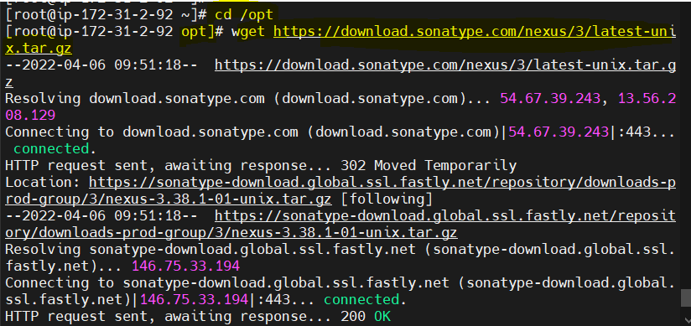

. ls

.tar –xvf <tarfile>

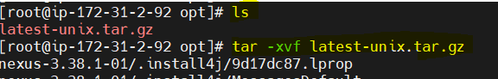

. moving nexus3

.mv nexus-3.34.0-01 nexus3

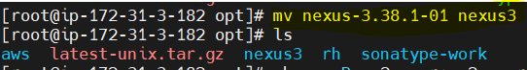

. change ownership🡺change directory🡺cd bin

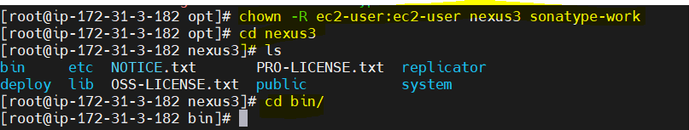

. ls🡺 vi nexus.rc

. delete comment(#),add user



. generate soft link

. ln -s /opt/nexus3/bin/nexus /etc/init.d/nexus



. change directory



. nexus server manage application

. start nexus server

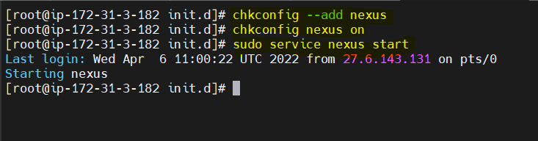

. nexus portnumber :-8081🡺login with nexus ip

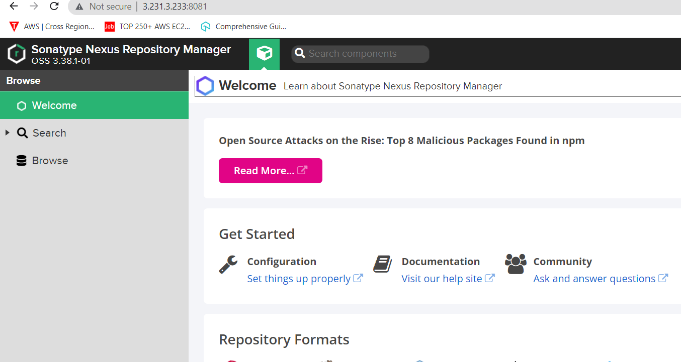

. sign in🡺 default user name admin🡺copy below path🡺cat <copy path>

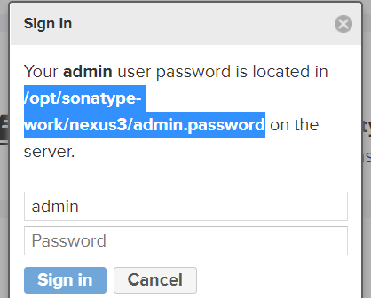

. go to mobaxterm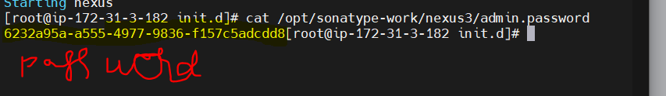

. sign in nexus dashboard🡺next🡺create new password

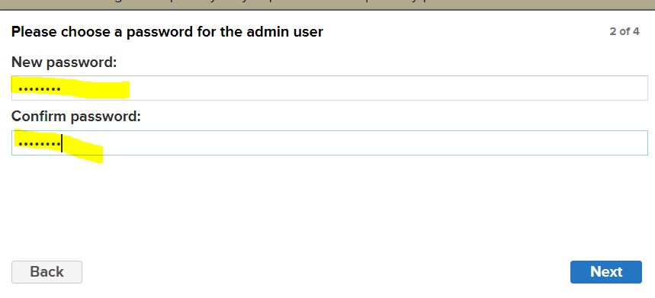

. next🡺enable🡺next🡺yes.

. we need two repositories

.go to settings🡺 click on repository🡺 create new repository(because the war file needs to be copied which means the repository is required)🡺 click on maven2hosted

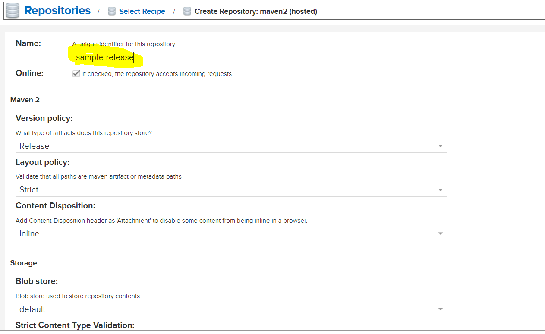

. create repository

. create another repository

